First electric vehicle for bin emptying

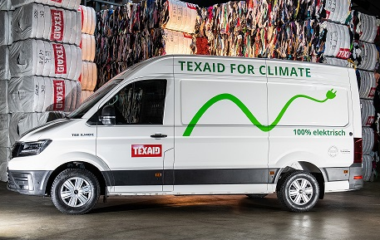
In the city of Basel, Texaid has recently started using an electric vehicle go around emptying the bins. This is a further step towards lowering the CO₂ emissions involved in used clothes collection in the long-term.
Texaid is continually expanding on their sustainability strategy and reducing their consumption of resources. Through diverse measures, CO₂ emissions were able to be reduced by 44 percent for each tonne of used clothing collected since 2013. These include, for example, purchasing electricity from renewable energy sources and reducing the number of road collection bags. This current measure, the purchase of the MAN eTGE electric vehicle for bin emptying in the city of Basel, represents another step forward for Texaid in their commitment to climate-friendly collection of used clothing.
First electric vehicle from MAN for the transport of used clothes bags.

Efficient bin collection thanks to special software
In order to empty the approximately 6500 used clothes bins in Switzerland, Texaid uses their own computer-based logistics system, which allows for an individual emptying interval for every single bin. The self-learning system monitors the expected or sensor-measured fill levels of the used textile bins and on this basis, automatically calculates efficient trips which achieve the maximum possible collection weight per vehicle with the fewest possible kilometres driven. This self-learning system will be perfectly complimented by climate-friendly hardware with the acquisition of the electric vehicle.

Hurdles for the expansion of the electric fleet
Initially, the electric vehicle will be in use in the Basel area, as there the bins and unloading points are located in relatively close proximity. In other areas, it will be more difficult to use an electric vehicle as the distances are greater, meaning that, therefore, the coverage, as well as speedy daily reloading must be proven in everyday work practice. Martin Böschen, CEO of Texaid group, stressed: “At present, however, the biggest problem for the expansion of the electric fleet is the load capacity. Due to the weight of the battery, the cargo load is only about 900 kilos, whereas we are able to carry about 1300 kilos in conventional vehicles.” Only vehicles with a maximum total weight of 3.5 tonnes may be driven with a category B driving licence. Politicians are now called upon to adapt the law so that in future light commercial vehicles or electric vehicles may be loaded up to a total weight of 4.25 tonnes and still be driven with a category B driving licence.

With a fleet of around 60 vehicles for bin emptying in Switzerland, Texaid’s potential for further CO₂ reduction would be very promising.

Texaid was founded in 1978 as a charity-private partnership between six Swiss relief organisations (SRK, Winterhilfe Switzerland, Solidar Suisse, Caritas Switzerland, Kolping Switzerland, HEKS) and an entrepreneur. With its headquarters in the Canton of Uri and branches in Germany, Austria, Spain, Bulgaria, Hungary, Morocco and the USA, the company is one of the leading service providers of textile recycling services in Europe. in Switzerland, Texaid has an ISO-certified quality and environmental management system (ISO 9001 & ISO 14001) and has been awarded the “CO2 Neutral” seal of approval by Swiss Climate AG. In Switzerland, Texaid employs approximately 130 people.

Additional information:
Texaid press office
Telephone: 041 874 54 16
Email: pressestelle@texaid.ch
Website: www.texaid.ch

Image material: The corresponding images are available on our homepage under Downloads.
Image caption: First electric vehicle from MAN for the transport of used clothes bags.

