Increased efficiency through innovation:
CHF 7.8 million for charity projects and a further reduction in CO₂

Texaid Textilverwertungs-AG has brought its latest financial year to another successful close. The amount of money donated to charitable organisations, the continued reduction in CO₂ and the increased commitment to research projects and associations are all particular points of pride.
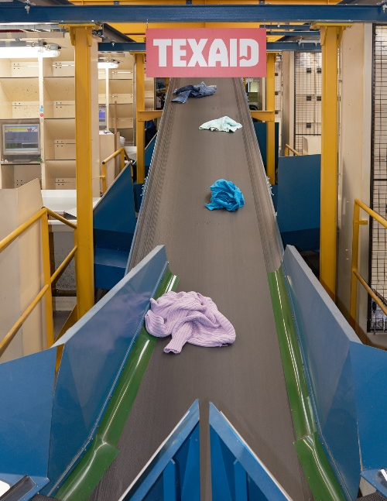
Last year, Texaid and its subsidiary Contex collected around 36,000 tonnes of old clothing, shoes and household textiles throughout Switzerland. This equates to approximately 140 million items of clothing handed in by members of the public via containers and by means of street and in-store collections. Texaid ensures that the textiles it collects are used in an environmentally friendly way. Whether they are worn again or made into cleaning cloths and insulation materials – old clothes are given a new life in the textile loop. This preserves valuable resources and considerably reduces environmental damage. Texaid generated 7.8 million francs from the sale of wearable old clothing, which it then donated to various charities for a range of projects. Furthermore, Texaid continued to develop its environmentally friendly corporate culture and reduced CO₂ emissions by 35 percent per tonne of old clothing collected with regard to the base measurement year 2013.

One of the most modern sorting plants in
Europe at the headquarters in Schattdorf (UR).

7.8 million francs for social projects
In 2017, Texaid raised around 7.8 million francs for charity thanks to the sale of wearable textiles. Of this amount, approximately 2.6 million francs went to the participating aid organisations: Swiss Red Cross, Winterhilfe Schweiz, Solidar Suisse, Caritas Schweiz, Kolping Schweiz and the Hilfswerk der Evangelischen Kirchen Schweiz. Texaid was able to provide a further 5.2 million francs to numerous Samaritan associations and other charity organisations. This money is put towards various social and sustainable projects regionally, nationally and even internationally. Two such examples are the games library for the blind and visually impaired in Zollikofen and the daycare centre for children from impoverished backgrounds in Peru.
More information about these and other projects can be found on the Texaid website.

A 35-percent reduction in greenhouse gases
Texaid is constantly expanding its sustainability strategy and reducing its consumption of resources. It has set itself the goal of reducing the CO₂ emissions caused by its own activities. Following various measures taken for the purpose of Swiss climate certification, around 35 percent of CO₂ per tonne of old clothing collected was saved last year (in comparison with the base measurement year 2013). The successful partnership with Swiss Post for street collections was among the factors which helped Texaid to achieve this goal. Mail carriers collect the old clothing during their daily rounds to ensure optimal synergies and to avoid empty runs.
Commitment to research projects and associations
Professional collection and high-quality sorting, as well as sustainable recycling and processing of sorted textiles, are becoming increasingly important in the face of the challenges posed by fast fashion. Textile recycling involves developing solutions which can help to close the loop in the textile cycle. In order to make its vision a reality, Texaid is taking action along the entire textile value chain and is committed to various organisations and research projects.

Texaid was founded in 1978 as a charity-based private partnership by six Swiss aid organisations (Swiss Red Cross, Winterhilfe, Solidar, Caritas, Kolping and HEKS), along with an entrepreneur. With its headquarters in the Canton of Uri and branches in Germany, Austria, Bulgaria, Hungary and Morocco, the company is one of Europe’s leading textile recycling service providers. Texaid has an ISO-certified quality and environment management system in Switzerland (ISO 9001 & ISO 14001) and has been awarded the “carbon dioxide neutral” label by Swiss Climate AG. Texaid employs around 130 members of staff in Switzerland.

Additional information:
Texaid press office
Telephone: 041 874 54 16
E-mail: pressestelle@texaid.ch
Website: www.texaid.ch

Photomaterial:
You can find relevant images on our website, under downloads.
Caption: One of the most modern sorting plants in Europe at the headquarters in Schattdorf (UR).

